Section 3 Building A Project

1. **Default:** 
   1. **<packaging> jar**
   2. **<activation><name>env.MY_ENV_VARIABLE 🡸 env. is prefix and MY_ENV_VARIABLE must be whole capital whereas in system, we may have defined environment variable in any case (small or capital) it does not matter.**
   3. mvn **archetype:generate 🡸 default is quick start archetype 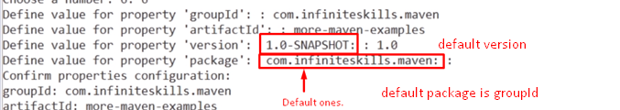 **
2. **d**